**NEWS DATA SET SCHEMA DESCRIPTION**

**Schema**:  
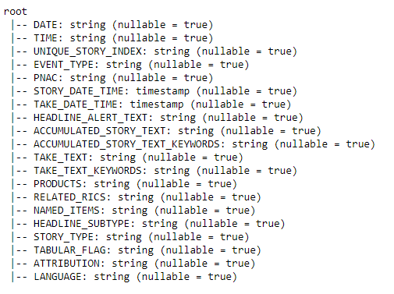

**Schema Description**

* DATE - <string_type>

Date of record entry

* TIME - <string_type>

Time of record entry

* UNIQUE_STORY_INDEX - <string_type>

Story ID

* EVENT_TYPE- <string_type>

Type of story event. Possible values extracted from the data set:

+--------------------+

| EVENT_TYPE|

+--------------------+

| HEADLINE|

| DELETE|

| STORY_TAKE_APPEND|

| ALERT|

|STORY_TAKE_OVERWRITE|

+--------------------+

* PNAC - <string_type>
* STORY_DATE_TIME - <timestamp>

Timestamp when story actually occured

* TAKE_DATE_TIME - <timestamp>

Timestamp when story was recorded

* HEADLINE_ALERT_TEXT - <string_type>

Headline of the story

* ACCUMULATED_STORY_TEXT - <string_type>

Description of the story gathered from sources

* ACCUMULATED_STORY_TEXT_KEYWORDS - <string_type>

Keywords extracted from the “ACCUMULATED_STORY_TEXT” column

* TAKE_TEXT - <string_type>

Description of the story from the reporter

* TAKE_TEXT_KEYWORDS - <string_type>

Keywords extracted from the “TAKE_TEXT” column

* PRODUCTS - <string_type>
* RELATED_RICS - <string_type>
* NAMED_ITEMS - <string_type>
* HEADLINE_SUBTYPE - <string_type>

Possible values extracted from the data set:  
+----------------+

|HEADLINE_SUBTYPE|

+----------------+

| null |

| 3|

| 5|

| 4|

| 2|

+----------------+

* STORY_TYPE - <string_type>

Possible values extracted from the data set:

+----------+

|STORY_TYPE|

+----------+

| null|

| D|

| S|

+----------+

* TABULAR FLAG - <string_type>  
  Possible values extracted from the data set:

+------------+

|TABULAR_FLAG|

+------------+

| null|

| false|

| true|

+------------+

* ATTRIBUTION - <string_type>

Possible values extracted from the data set:

+-----------+

|ATTRIBUTION|

+-----------+

| null|

| RTRS|

+-----------+

* LANGUAGE - <string_type>

Language of the story. Possible values extracted from the data set:

+--------+

|LANGUAGE|

+--------+

| null|

| AR|

| CS|

| DA|

| DE|

| EL|

| EN|

| ES|

| FR|

| IT|

| JA|

| KO|

| NO|

| PL|

| PT|

| RU|

| SV|

| TH|

| TR|

| ZH|

+--------+

**Sample View of the curated data set:**

1.

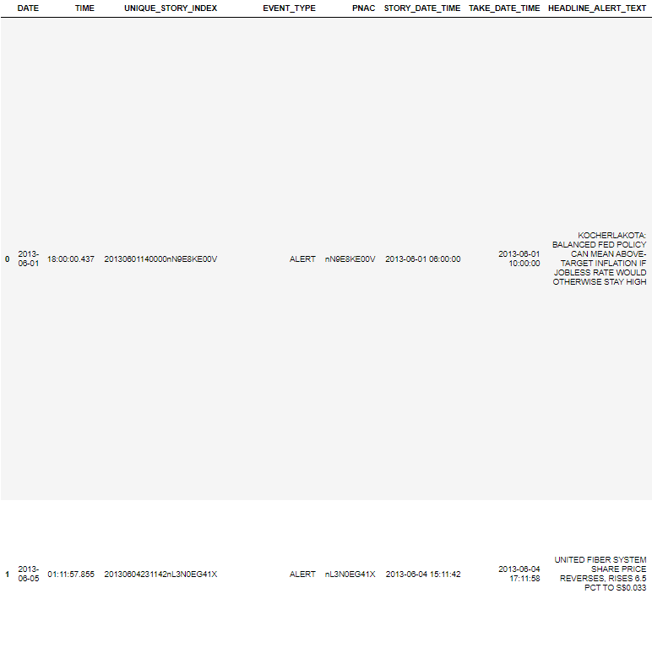

2. 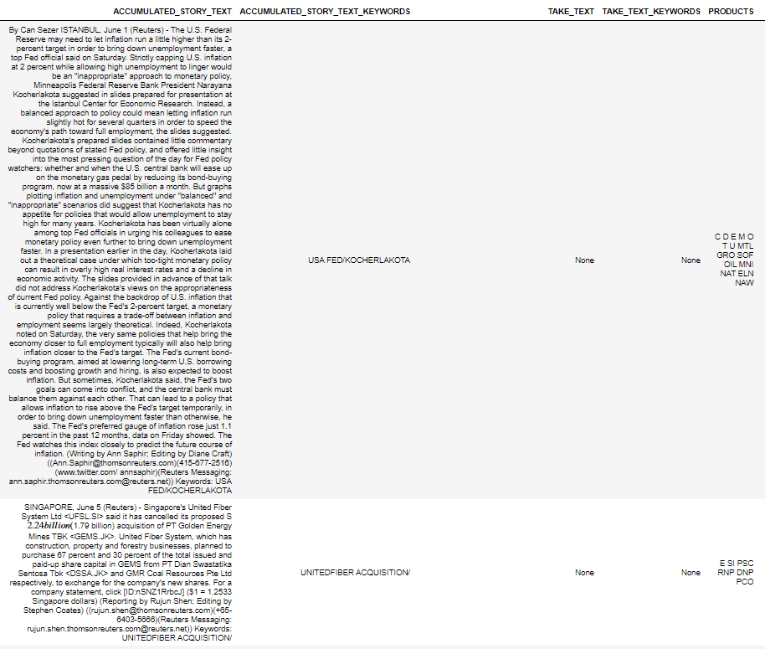

3.

